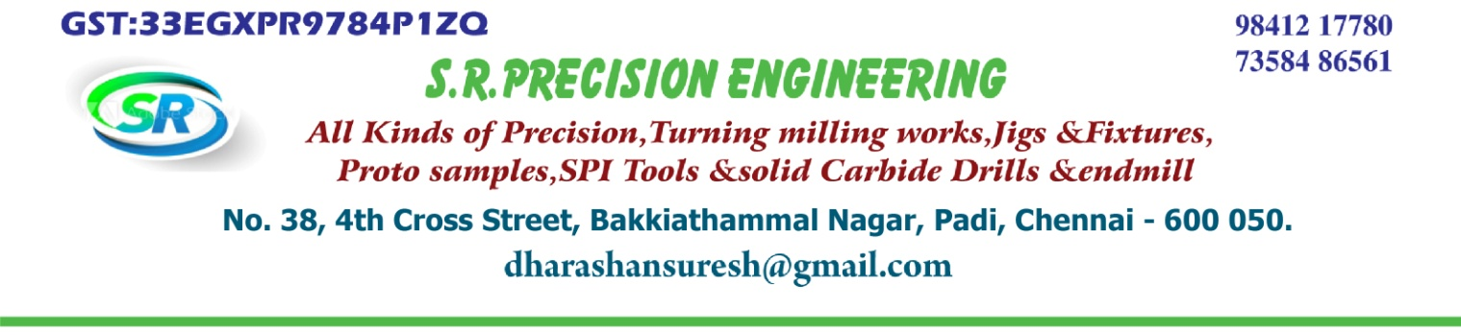
Mr. SANTHOSKUMAR
M/s ABHINVARIZEL (P) LTD
CHENNAI-600072
SUB : COUPLER

Dear Sir,
We submit our lowest quotation for the following items.
Sl. No. | Description | HSN  Code | QTY | Rate Each | Amount
1. | ARO40649 COUPLER OD AND ID SPARKING PROCESS | 8482 | 1 NOS | 4000.00 | 4000.00
GST 18% Extra

Thanking you

For S.R. PRECISION ENGINEERING


